SNMP Trap Receiver

Quick Start Guide

SW-PS-14500.1

July 6, 2012



**Solutions Group**

555 Richmond Street West

PO Box 110

Toronto, Ontario

Canada, M5V 3B1

Tel: +1 (416) 868-0152

Fax: +1 (416) 868-4867

<http://www.uptimesoftware.com>

[info@uptimesoftware.com](mailto:info@uptimesoftware.com)

# Table of Contents

Table of Contents 2

1 Introduction 3

2 SNMP Trap Scripts Configuration 4

3 Trap Receiver Configuration 5

4 up.time Configuration 11

# 1 Introduction

The purpose of this document is to provide the instructions on how to easily deploy a trap listener host in your infrastructure to drive SNMP trap alerts into up.time.

# 2 SNMP Trap Scripts Configuration

1. Extract the zip file
2. Put the files in an appropriate directory (e.g. C:\uptime)
3. Open Trap_Receiver.bat and look for the “SCRIPT_DIR” variable. Change it to where you have put the scripts in step 2.
4. Open Trap_Receiver.vbs and modify a few variables if needed:
   1. MonitoringStationHost

…this is where the up.time Monitoring Station is installed. Make certain the hostname/IP used can communicate from where the scripts are to the Monitoring Station.

* 1. MonitoringStationPort

…this is the port up.time uses for the API. By default it’s 9996.

* 1. AlertStatus

…this is the severity of the alert in up.time when an SNMP trap is received.

The value can be one of the following integers:

0=OK

1=Warning

2=Critical

3=Unknown

# 3 Trap Receiver Configuration

1. Download Trap Receiver from the following website:

[http://www.trapreceiver.com](http://www.trapreceiver.com/)

1. Install Trap Receiver
2. Launch the Trap Receiver UI
3. Click on the “Configure” button:

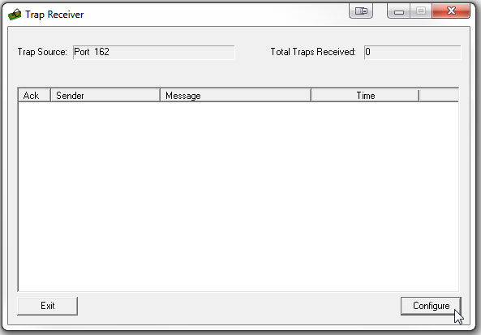

1. You should be at the “Actions” tab. Click “Add”:

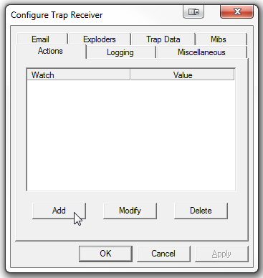

1. Since the IP of the device sending out SNMP traps might be displayed differently in up.time, a separate action should be created for each device so that the proper hostname can be passed to up.time.

To add a new action tied to a particular IP:

* 1. Under “Watch”, select “Sender IP”.
  2. Under “Equals”, input the IP Address of the device that will be sending the SNMP Traps.
  3. Check the “Execute” checkbox and click “Configure”

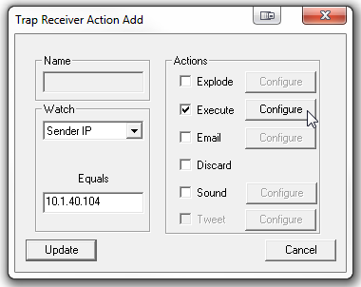

* 1. Click on the “…” button and select the “Trap_Receiver.bat” from Section 3 Step 2
  2. In the Arguments box, type the following:

--hostname=yourDeviceName

…where “yourDeviceName” is the “Host Name” in up.time. The “Host Name” can be found under the “Info” tab in up.time. For example:

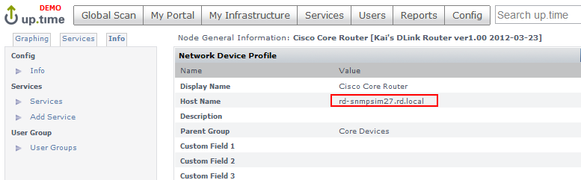

* 1. Check the “Include Trap Data” checkbox. See below:

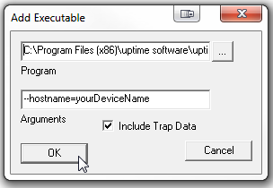

* 1. Click “OK”
  2. Click “Update” to get back to the Configure Trap Receiver window.

1. Go to the “Trap Data” tab
   1. Check the “Pass to Command Line” checkbox
   2. Click “Specify Parameters”

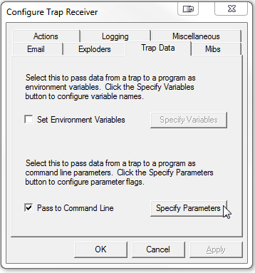

* 1. Make sure the following lines are checked and the Command Line Flags are as follow:

|  |  |
| --- | --- |
| Variable | Command Line Flags |
| Ip Address | IpAddress |
| Varbind Data | VarbindData |
| Varbind OID | VarbindOID |

The end result should look like this:

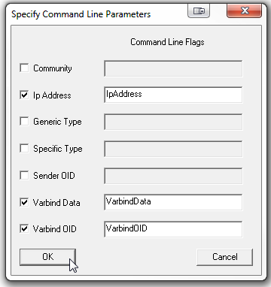

* 1. Click “OK” when complete

1. The SNMP variables, by default, will be shown as numbers (e.g. 1.3.6…). To show more meaningful variable names, you will need to load the appropriate MIBs from your devices.

Go to the “Mibs” tab in the “Configure Trap Receiver” window

* 1. Check the “Translate OIDs” checkbox
  2. Obtain vendor-specific MIBs and load them by clicking the “Load MIB” button

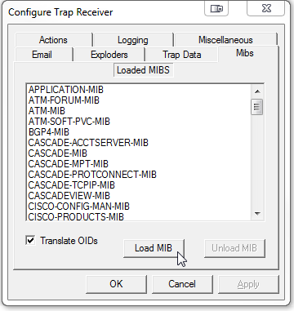

* 1. Click “OK” when finish loading MIBs

# 4 up.time Configuration

1. Create a Service Group in up.time. See <http://support.uptimesoftware.com/article.php?id=341>

You may choose to put all your devices in an Element Group and all the Element Group to the Service Group. Call the Service Group “SNMP Trap Group”.

1. Add an “External Check” Service Monitor in up.time:
   1. Click on the “Services” button at the top
   2. Click “Add Service Monitor” on the left
   3. Select “External Check” from the list of available Service Monitors and click “Continue…”
   4. Input “SNMP-Trap” as the Service Name
   5. Click on the “Service Group” radio button and pick the Service Group you created in the previous step (i.e. “SNMP Trap Group”)
   6. Click “Finish”